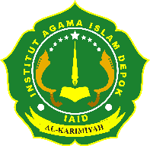
INSTITUT AGAMA ISLAM DEPOK
IAID AL KARIMIYAH
SK. Menteri Agama Republik Indonesia No. 1499 Tahun 2022
Jl. H. Maksum No.23 Sawangan Baru Kota Depok Telp. (0251) 617335
Website : www.iaidepok.ac.id

UJIAN AKHIR MATA KULIAH
GANJIL 2023/2024

Nama | : ..................................................
NIM | : ..................................................
Mata Kuliah | : ..................................................
Hari/Tanggal | : ..................................................
Semester | : ..................................................

